HILLY FIELDS FOOTBALL CLUB
SEASON 21: 1987-88
Beckenham League Veterans Cup
P W D L F A
Cornish Vets 1 1 0 0 7 3 aet
Addington Manor 1 1 0 0 4 0
Villacourt Rovers 1 0 0 1 1 4
TOTAL 3 2 0 1 12 7

Apps Gls Apps Gls
Adrian Bennett 2 0 Ray Griffin 3 0
Steve Chitty 3 0 John Macrea 3 0
Damien Cole 1 0 John McGilvray 2 0
Ron Davis 1 0 Tom Pollard 3 0
John Felton 3 0 Frank Ryan 2 1
Keith Foster 1 0 Bobby Satchel 2 2
Larry Garnham 3 2 Ralph Stanton 1 0
Brian Green 1 0 Terry Taber 3 1
Chris Green 3 6 Dave Wright 2 0
Malcolm Hill 1 0

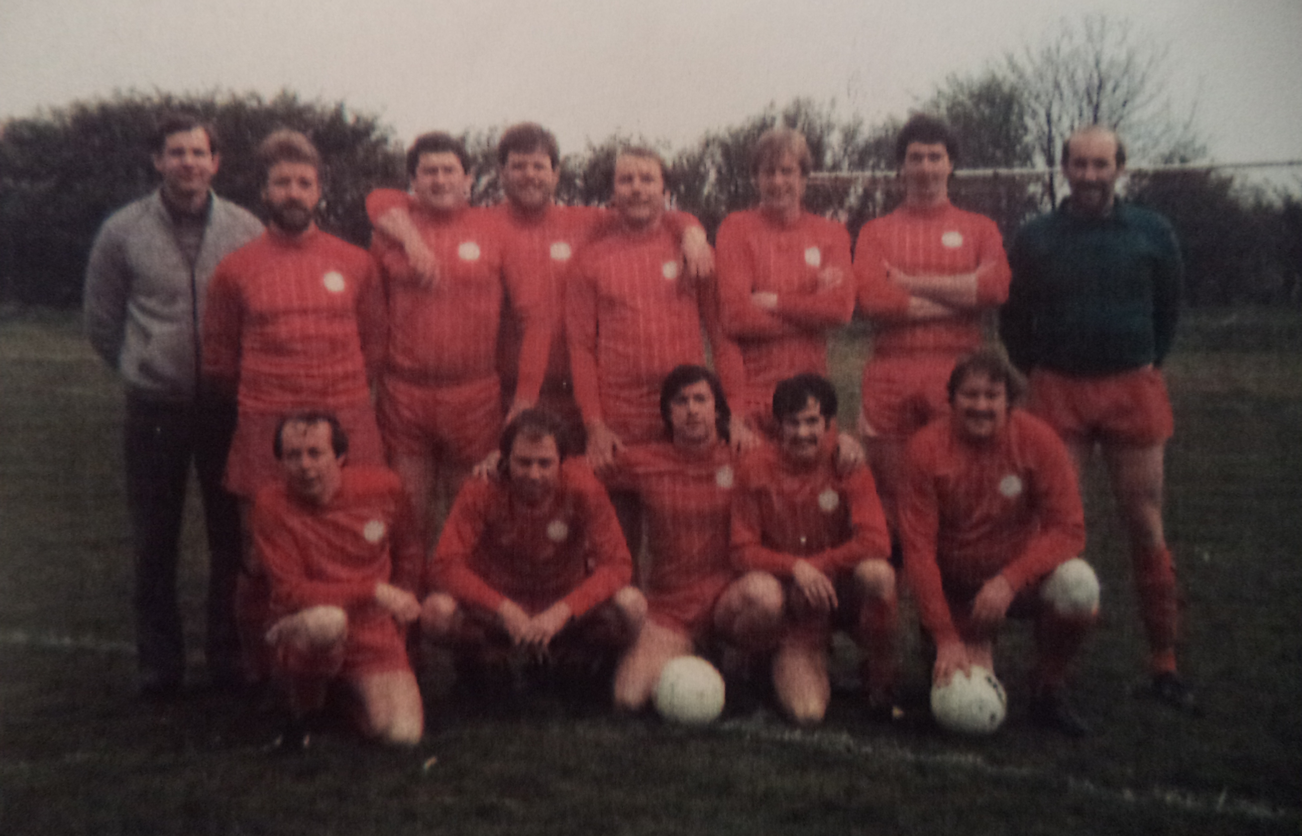
L-R Back: Keith Foster, Steve Chitty, Len Franklin, Colin Chandler, Tom Pollard, Larry Garnham, Frank Ryan, John Macrea. L-R Front: Ray Griffin, Chris Green, Ron Davis, John McGilvray, Brian Green.

